Extreme Line Following
Each robot will get two attempts to complete the course, and their best time will be recorded.
This event will take place on a ~4’x4’ whiteboard with the line constructed of 5/8” electrical tape. The course will include long straight-aways, curved turns, and sharp angled turns (see attached drawing).
Robots will begin at the starting “gun” (wooden clapper) and their time over the course will be recorded when they come to a stop after touching the stop-block.
Robots must use a light sensor to follow the line, but may use any other sensor(s) to supplement performance. (Hint: notice the 12”x12” boards located at key locations)
No external stimuli may be supplied during the run.
Touching the robot after the “gun” and before touching the end block will result in a 30s penalty time added to the recorded time of the run for each time the robot is touched, or, the team may choose to pick up their robot at any time, resulting in the end of that opportunity.
The winner will be the team bot that runs the challenge in the shortest elapsed time and stops running as a result of touching the wood block at the end of the course. Should no team complete the course, the winner will be the bot closest to the finish with the best time.

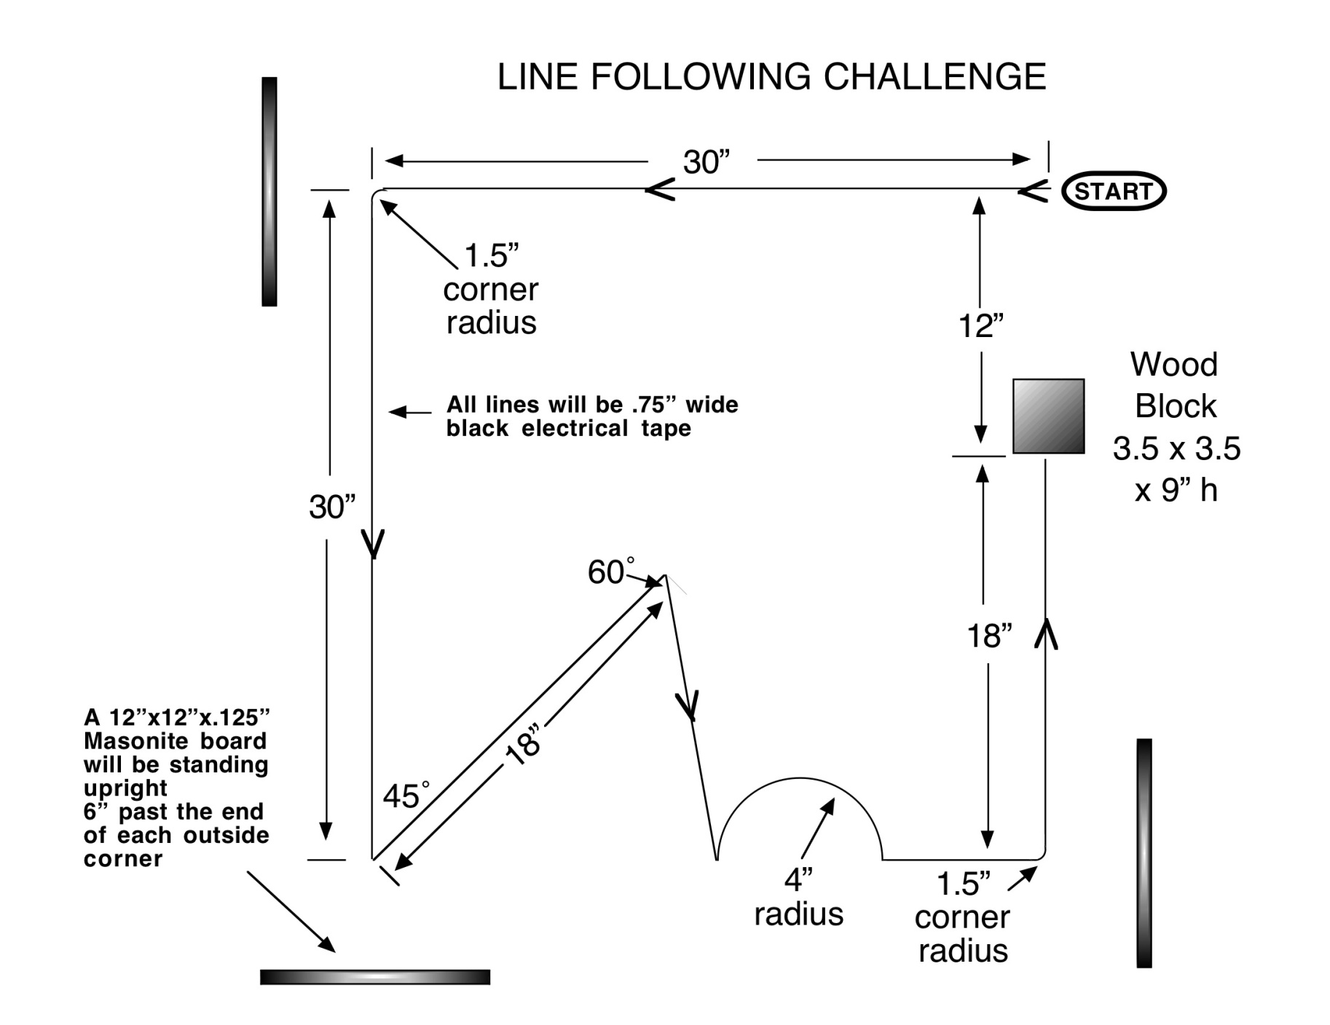
Extreme Robo-Navigation Layout

